ISO/IEC 27001:2022
Information Security Management Systems

General
This questionnaire will help our customer teams understand your needs and to determine how best to address your requirements.

Company Name
Industry
Contact Name
Job Title / Role
Phone
Mobile
Email Address
Business Address

Where did you hear about us?
When do you expect this project to start?
Please provide some background to the challenges you are looking to fix or improvements you want to make.
What is your expected/vision of the end-result?

DOCUMENT SCANNING

Estimated Timeline:
- Estimated volume: How many pages do we need to scan?
- Estimated number of pages per document: Please complete the table provided below …
- What type of documents require processing? (Accounts Payable, Accounts Receivable, HR 201, Medical Records, Legal Documents, Quality Assurance Documents, Others?)
- Number of index fields per document: An index field pertains to a keyword reference to the scanned image. When you do a search and retrieval of document image, this is the keyword you use to do a search. Here’s a helpful guide to determine your index fields https://archive-one.net/suggested-indices
- Paper size – i.e. A4, legal size, letter size, A3?
- What is the quality of the paper records? Rate 1 to 5 (1 = very poor, 5 = perfect)

What will be the format of the output?
  - PDF / TIFF?
  - Greyscale (scanned image that contains only shades of gray and no color)?
  - Colored?

Where do you want us to do the scanning?
  - Customer’s site
  - Paperless Trail Inc. (PTI) site

 | Department | Document Type | Average Number of  Pages | Index Requirements
1 | Finance | Cash Voucher | 5 | 3-5
 |  | Invoice | 2 | 3-5
 |  | Official Receipt | 1 | 3-5
 |  | BIR | 1 | 3-5
2 | HR | Resume | 2 | 3-5
 |  | NBI | 1 | 3-5
 |  | Government | 1 | 3-5
 |  | Contract | 5 | 3-5
 |  | NDA | 5 | 3-5
 |  | Memo | 2 | 3-5
 |  | Medical | 2 | 3-5
3 | Company | Memo | 2 | 3-5
 |  | SEC | 3 | 3-5
 |  | Permits | 1 | 3-5
 |  | Policies | 3 | 3-5
 |  | Accreditation | 5 | 3-5
 |  | Administrative | 2 | 3-5
4 | Legal

Estimation Guide

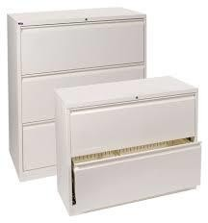
5,500 – 6,000 Pages Per Horizontal Drawer

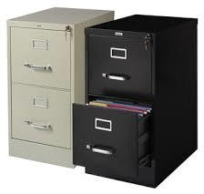
2,000 – 2,500 Pages Per Vertical Drawer

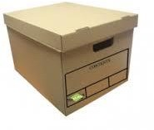
2,000 – 2,500 Pages Per Box

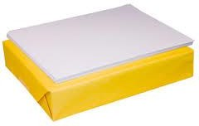
500 Pages Per Ream

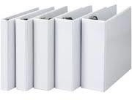
3” – 650 to 680 Pages Per Binder
2” – 430 to 480 Pages Per Binder
1” – 250 to 260 Pages Per Binder

Indexing Guide

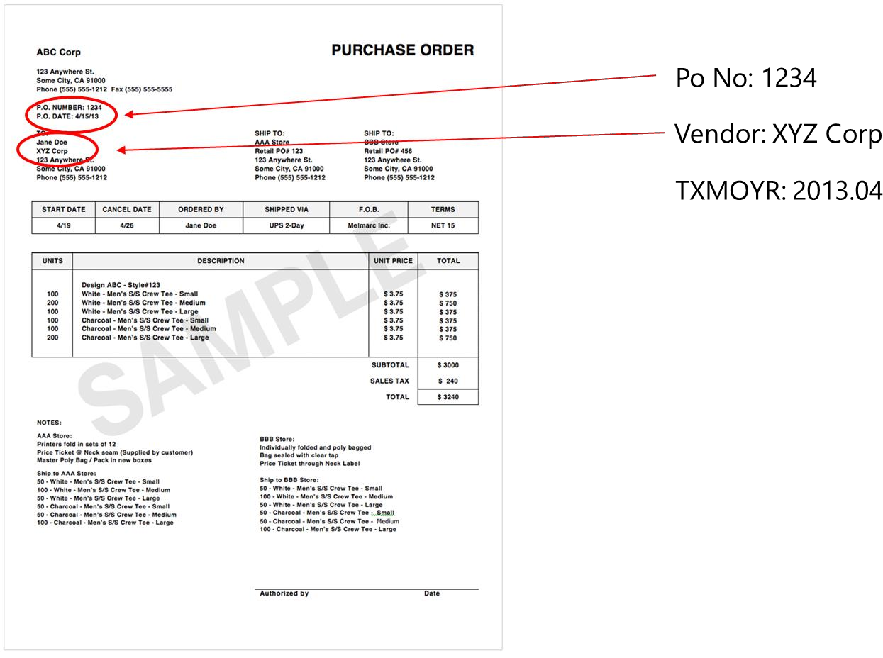
Note:
TXMOYR = Transaction Month Year - Helps with finding your documents for audit activities.
